**AUTOMATION OF THE PRODUCTION OF PUBLIC TRANSPORT CHAIRS**

It is a personal project of Yovany Vargas, a mechatronics engineer. Aimed at learning, improving, and demonstrating skills in automation and economics. The project’s approach is to create a production line of Colombian public transport chairs, which includes three different models, as shown in ***Figure 1***. The production line must have one or more robotic cells, SCADA system with a local database, as well as 4.0 industry and IIoT technologies. The project also includes an economic proposal with relevant performance indicators, with all decisions justified.

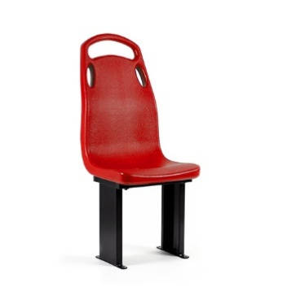

**a**. Tall supports individual chair

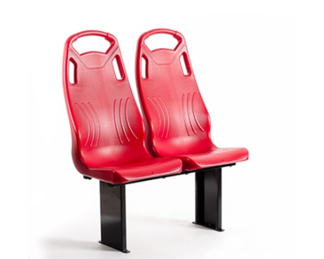

**b**. Tall supports double chair

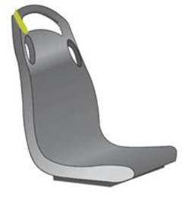

**c**. Flat support

**Adapted from**: Promiurban & Caelca

**Figure 1**. Chair models

Additionally, the engineer uses PM4R ([www.pm4rglobal.org](http://www.pm4rglobal.org)) for project management, and the methodology will be detailed in the final report and repository readme ([github.com/Yonvay/AUCHAIR](https://github.com/Yonvay/AUCHAIR)). It is a public project licensed under MIT, allowing anyone to see, use, copy or provide feedback on the work, with fast answers from the engineer.

***Yovany Vargas, 2025***